Who is to blame for the alarming spread of HIV in Pakistan?

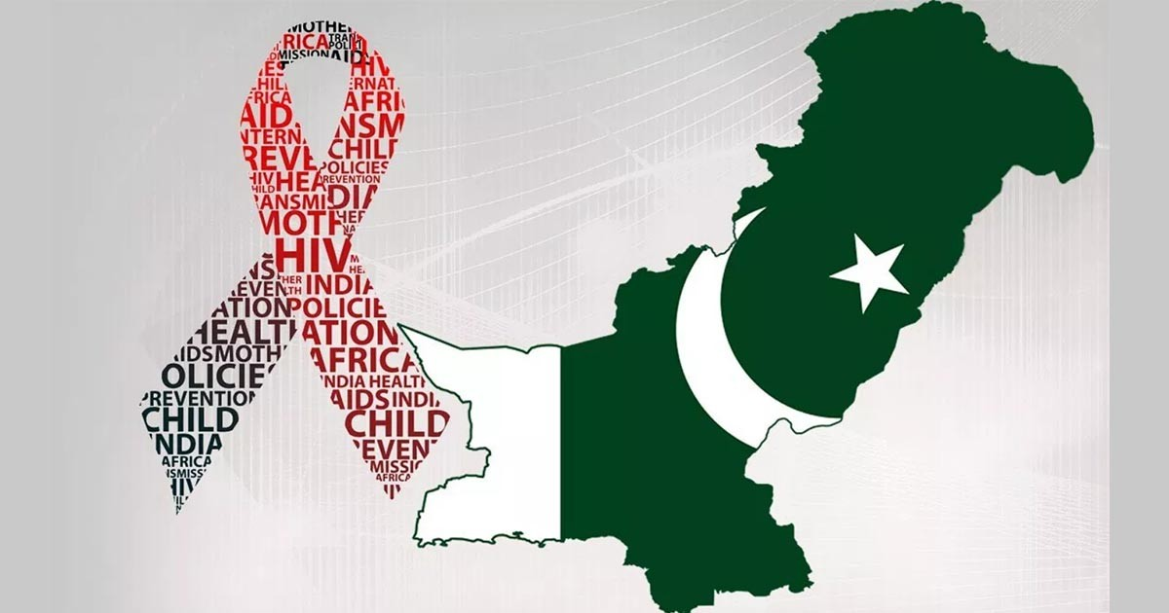

As Muslim countries increasingly are having to tackle this growing challenge, Pakistan is in the midst of an HIV epidemic, with new infections growing by 84% since 2010. A staggering 9,773 people have been tested positive during the first 10 months of 2022 as per data released on 25th November 2022. By many accounts, this is only the tip of the iceberg as testing is inaccessible to many and the stigma attached to HIV. Islamabad has by far the highest numbers of new infections, 496, when compared to other regions in terms of population and area. Officials of the National Health Services, Regulations and Coordination (NHS,R&C) remarked that “HIV is now spreading to general population from the key populations including people who inject drugs, sex workers (male, female and transgender) and those involved in homosexuality”.
What is even more worrying is that a significant percentage of low-risk males, females, and clients of key populations are the newly infected ones suggesting an increase in HIV transmission to bridge populations (spouses, partners, and clients) of key populations according to UNAIDS. This phenomenon of HIV now spreading from already high-risk people termed as key populations to the otherwise low-risk people called bridge populations is a serious threat to the whole country. Bridge populations are a critical group because of their ‘mobility with HIV’ and the consequent spread to the general public.
HIV Outbreaks in Pakistan
Until 2003, Pakistan was categorized as a low-prevalence HIV country. Of the four HIV outbreaks in Pakistan so far, the first was detected in 2003 and the last one as early as 2019 in Larkana, Sindh. All of these outbreaks were either due to unsafe medical practices and procedures or amongst drug addicts who share syringes.
The recent surge in cases is, however, more distressing because the dominant share being that of Men-who-have-Sex-with Men (MSM) and sex workers, particularly transgenders. Renowned infectious diseases specialist and expert on HIV Dr. Faisal Mehmood points out MSM as one of the major reasons behind rising HIV cases as compared to the past. He said, “MSM is one of the biggest key populations in which HIV is spreading fast in Pakistan”.
What is more distressing is the response of our policy-makers, who instead of addressing the root-cause are busy with tackling the symptoms and in the process justifying these types of activities and behaviours, though these are in flagrant violation of the cultural norms and strictly prohibited in Islam. The National HIV and AIDS Policy drafted in 2007 offers ‘condoms’ for sex-workers as a solution for HIV prevention. This is utterly unacceptable. Instead of spreading awareness from early on about the prohibition of MSM and other forms of sexual liberalism, preventing its promotion and strictly prohibiting it by law, successive governments have promoted such behavior by advising it to be done safely.
Attitude of the leadership in Pakistan
Are the rulers unaware of the very clear and strict verses of the Quran where such behavior is angrily chastised by Allah (swt), be it fornication or homosexuality? Or the Hadith of our noble Prophet (saw) condemning these acts in the most blatant words? Isn’t the hadith enough to open our eyes (and hearts) towards the warning of Allah (swt) wherein we were told more than 1400 years ago about the coming of diseases such as AIDS, if we were to transgress and engage in such disgusting sexual acts?
Shameless Acceptance
While the origin of AIDS can be debated, the most common mechanism of its spread is well established and therefore leaves us with no justification to not nib the evil in the bud. What we are seeing is quite the opposite, a full-fledged campaign to promote these evils in society, by granting them legal protection, pushing them through media, particularly films, and glorifying the culprits. As if Western originated movies were not bad enough, they have started to finance homegrown production of such content, Joyland being the most glaring example. The movie, before its official release, had already bagged 4 major awards, among them the ‘prestigious’ Cannes Film Festival award in two categories; the Queer Palm category given to LGBT-relevant content and the much-acclaimed jury prize. Joyland’s crew received an 8-minute standing ovation at the Cannes Film Festival, a clear indication how important the promotion of such content in our countries is to the West.
The West in no position to lecture Pakistan
What is the contribution of this lewd content to humanity that deserved such outpour of support and recognition? The modus operandi for spreading this vice isn’t unknown to the world. This is the same way LGBT was introduced in the West; granting it a legal cover first and then constructing a favorable opinion among the masses through media. They didn't even spare children’s cartoons, schoolbooks and storybooks. What started as a campaign for more rights for transgender communities around the turn of the millennium has so far ended up in 32 countries legalizing same-sex marriage, and still counting. The latest country to be considering such legalization happens to be our neighbour, India, who is home to the world’s second-largest Muslim population but sadly also the third-largest population of persons with HIV/AIDS. The United Nations, which Pakistan so proudly is a member of and Afghanistan is so eager to become a member, considers laws criminalizing consensual same-sex relations between adults to be in violation of international human rights law. USAID is very vocal for its support of LGBT+ rights on one hand and very active in Pakistan, particularly in the Education sector.
The West has no moral basis or authority to lecture or impose its decadent values upon Pakistan or any part of the Muslim world. Vice and immorality are rife in the West with ominous statistics that are widely available online indicating the extent of moral decline taking place. As for HIV:
- Approximately 1.5 million new HIV infections occurred last year—more than 1 million more than the global targets. In too many countries and for too many communities, we now see rising numbers of new HIV infections
- Every two minutes in 2021, an adolescent girl or young woman was newly infected with HIV
- The AIDS pandemic took a life every minute in 2021, with 650,000 AIDS-related deaths despite effective HIV treatment and tools to prevent, detect and treat infections.
This the burden for any society by following this immoral and corrupt path.
Next Steps
The next steps are clear, LGBT propaganda will become part of our textbooks and curricula just as it has been granted legal cover through the Transgender Act of 2018. This hypocrisy of being an ‘Islamic’ country and at the same time going against clear Islamic injunctions should stop. It is the responsibility of every one of us, as individuals or members of society, to raise our voice against this new wave of Western liberalism, for the alarm bells are already ringing in the form of formidable statistics; those of HIV bring just one such example to light.

Written for the Central Media Office of Hizb ut Tahrir by
Dr. Abdul Baseer

“And come not near unto adultery. Lo! it is an abomination and an evil way” [Al-Isra’ 32] “And those who do not invoke with Allah another deity or kill the soul which Allah has forbidden [to be killed], except by right, and do not commit unlawful sexual intercourse. And whoever should do that will meet a penalty. Multiplied for him is the punishment on the Day of Resurrection, and he will abide therein humiliated.” [Al-Furqan 68-69]
“And [We had sent] Lot when he said to his people, "Do you commit such immorality as no one has preceded you with from among the worlds? Indeed, you approach men with desire, instead of women. Rather, you are a transgressing people." [Al-A’raaf 80-81]
“When a person commits adultery he casts away from his neck the bond that ties him to Islam; if, however, he repents, Allah will accept his repentance”. (Al-Bukhari, Muslim, Abu Dawud, An-Nisa’i and others). “When promiscuous behavior becomes rampant in a nation, Allah will send upon them such (strange) diseases that their own ancestors never heard of.” (At-Tabarani)

