How Did “Tahrir al-Sham” Deal with the “Hizb ut Tahrir” in Northern Syria?
(Translation)
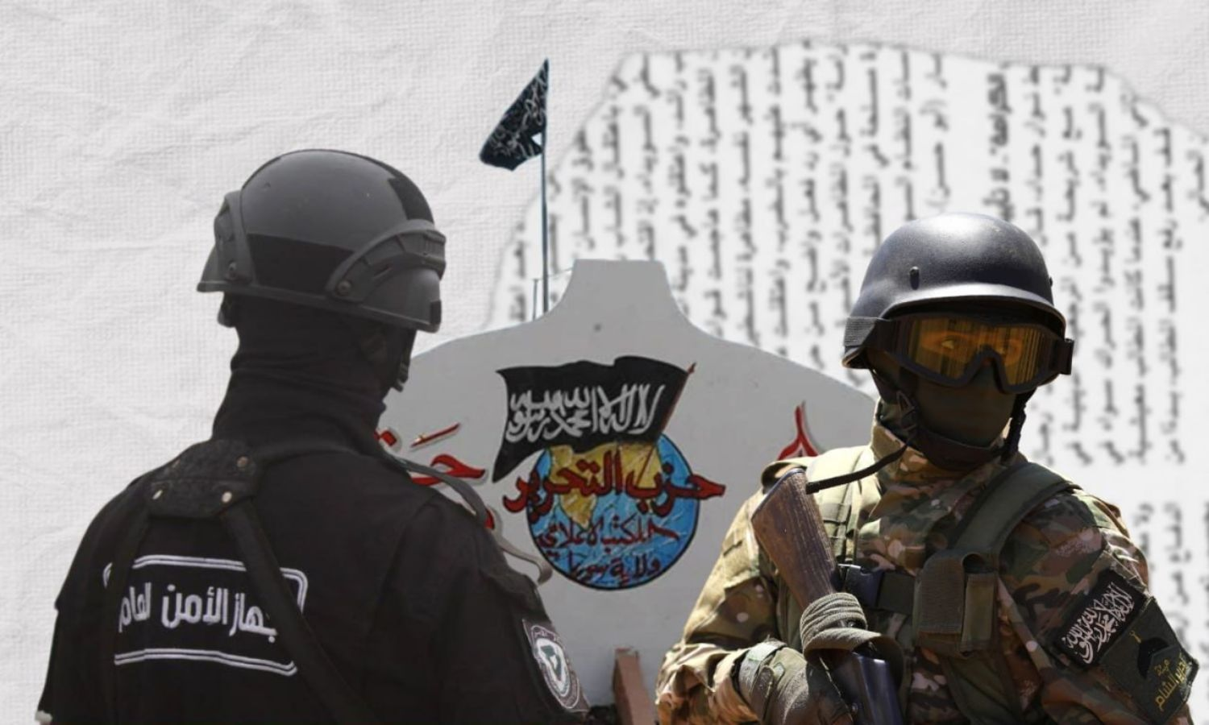
A member of Hayat Tahrir al-Sham, Public Security, and the Rayah banner of Hizb ut Tahrir (edited by Enab Baladi)
23/05/2023 Enab Baldi
Security tensions and restrictions are still present in several towns and villages in northern Syria. This is since the raids and campaign of arrests launched by the “Public Security Apparatus” operating in Idlib, against family members belonging to “Hizb ut Tahrir.”
Since 7 May, there are demonstrations, night and day, with demands from the people, in Deir Hassan, Killi, Al-Sahara, Babka and Al-Atareb, insisting on the release of detainees in the prisons of “Hay’at Tahrir al-Sham,” which controls the area, whilst rejecting the policy of “arbitrary arrests” that it is implementing.
Members of Hizb ut-Tahrir, an Islamic political party that does not recognize the borders of nation states, whilst calling for the return of the Islamic Khilafah, accuse the “Tahrir al-Sham” of “gagging mouths, imitating the repressive regime’s method and freezing fronts.” This is whilst “Tahrir al-Sham” accuses the Hizb of “dividing rows, betraying those who guard frontiers and spreading rumors.”

“Raid, Arrest and Assault”
On the morning of 7 May, the “Public Security” launched a campaign of arrests and raids on the homes of Hizb ut-Tahrir members, without official or legal warrants, according to the testimonies of people in the area.
Video recordings showed the raid of the “Public Security” forces in the early hours of houses in the village of Deir Hassan. They entered them through the walls. It caused a wave of widespread criticism, as fear-inducing actions, in line with the policy of the Syrian regime.
Enab Baladi obtained testimonies from three collaborative sources in the village of Deir Hassan. They stated that members of the “Public Security” stormed the homes, “without any official notification, and without regard for the sanctity of homes and honor.” They used equipment to smash a wall surrounding one of the doors of the houses.
“During the demolition process and the attempts to prevent the soldiers, a woman’s hand was injured, and another woman miscarried, in addition to the state of terror and fear that arose in the village,” the sources added.
The arrests targeted 18 people in the village. Most of them are members of Hizb ut Tahrir. The “Public Security” arrested two children under the age of 18 (among the toll).

Gunfire
The atmosphere remained tense until 6:00 pm that day, when about 150 residents gathered to issue a statement, through a video recording, condemning the arrest.
The sources stated that the gathering dispersed. About 15 people gathered in the home of the head of the Media Office of “Hizb ut Tahrir, Wilayah Syria,” Ahmed Abdel-Wahhab, in order to console the detainees’ families. The people of the village were surprised when the “Public Security” vehicles entered with 30 to 40 personnel.
The soldiers started firing heavily in the air, amid a state of “fear and panic” that the people found themselves in. A young man in the village was wounded in the foot. The people went out towards the village square. There was a stampede and an exchange of stone-throwing, between them and the soldiers.
The sources stated that the people did not carry any weapons. They denied what was said about the “Public Security” staging an ambush. However, the exit of a group of 15 people from the house suggested that.
The sources said that the people participated in the transfer of two soldiers of the “Security” who were wounded by gunfire to the hospital. This was amid speculations from the sources that the shooting was friendly fire by the soldiers.
Activists and local social media pages circulated a video of a “Public Security” vehicle with an injured member, who was said to have been killed. The “Public Security” stated that one member was killed and two were wounded.

12 Arrested
The sources stated that after the injured were transferred, the people were surprised when the “Public Security” entered the village, as “they arrested a number of people, without distinction of age, between young people, children, the elderly, and people who were not even there during the clashes.”
The next day, several people were arrested, including a mechanic and an owner of a coffee shop, amongst others who work outside the village. They were arrested upon their return. Dozens of people left the village for fear of being arrested, according to the sources.
There are more than 40 to 50 persons who are being pursued and in hiding, just because they are “relatives of detained persons.” After that, the “Public Security” released some persons, whilst 12 persons are currently detained, and they are:
Ahmed Mohamed Mansour.
Ahmed Mohamed Abdel Wahab.
Jihad Ahmed Mansour.
Ibrahim Ahmed Abdel-Wahhab.
Ahmed Zakaria Al-Dhalea.
Fares Zakaria Al-Dhalea.
The child Ahmed Omar Al-Dhalea (14 years old).
The child Youssef Muhammad Al-Dhalea (14 years old).
Mostafa Mohamed Al-Dhalea.
Muhammad Abdul Karim Al-Dhalea.
Hossam Mohamed Al-Zayyat.
Shady Fawzy Abdel Raouf.

“Seizing” Homes and Suppression
The sources explained to Enab Baladi that the “Public Security” seized seven houses, and turned them into military headquarters. The homes belong to,
Ahmed Mohamed Omar Mansour.
Mustafa Najjar.
Muhammad Mustafa Al-Dhalea.
Omar Mohammed Mansour.
Mostafa Mohamed Al-Dhalea.
Ahmed Abdel Wahhab, nicknamed “al-Mukhtaar.”
Jihad Mansour.
The “Public Security” agents seized a water filtration plant and the “Tasnim” factory, owned by Jihad Mansour. The plant was converted into headquarters. The plant was dismantled and the filters were confiscated, according to the testimonies of the sources.
Enab Baladi obtained local testimonies from five people in Deir Hassan, who stated that the “Public Security” has set up several checkpoints in the village’s streets and on its outskirts. This was amidst an atmosphere of persecution in the village, manifesting as raids and storming of homes, under the pretext of searching for wanted persons.
“We live in a state of terror. You feel that behind every rock there is a security person. Every five to six hours, there is a campaign of raids on specific homes,” said one of the local residents.
The families of the arrested persons, and those whose homes were seized, have moved to the homes of their relatives since 7 May.
The resident’s demands continue to hold the aggressors accountable for violating honor and the sanctity of homes.
Enab Baladi contacted the media office of the “Public Security Apparatus.” He requested clarifications regarding the confiscation of homes and their conversion into military headquarters, and the state of restrictions imposed by the “Apparatus” on the village. However, he did not receive a response, until the moment of preparing this report.

The Influential Denounce
A member of the “Deir Hassan Shura Council” (Enab Baladi refuses to reveal his name for security reasons) said that in the village there is a “Shura council.” It includes influential and notables since 2016. They stood apart, regardless of any party or faction, from everyone. They refused any infighting and they did not harm any “Mujahid.”
He added that the raising of voices in the village years ago made “Tahrir al-Sham” resent its people and raid them, regardless of any affiliation. He pointed out that members of the “Hizb ut Tahrir” had previously called on the “Hayat at-Tahrir” to mention a release, or even people from the Hizb, who had harmed or betrayed the “mujahideen” or they called for infighting. However, they could not.
He added that the issue of the mujahideen and sacrifices has become a “stake” used by “Tahrir al-Sham” to harass any party, faction or influential. He pointed out that Hizb ut Tahrir is neither born of today, nor of the Revolution. However, “the accusation is prepared.”
He pointed out that members of Hizb ut Tahrir and influential have been previously arrested, by several factions, whether from the “Nour al-Din Zinki” movement, under the pretext of belonging to “al-Nusra” and vice versa. These parties are throwing accusations at them because they are not in line with any faction’s project and policy.
Hizb ut-Tahrir defines itself as a “political party founded in 1953. Its ideology is Islam and its work is political. It works to resume the Islamic way of life and carry the Dawah to the world.” Its activity is not concentrated in a specific country. It does not recognize the nation state. The Hizb party considers the whole world as an appropriate place for the Islamic Dawah. The Hizb does not have an armed wing.

Source: https://www.enabbaladi.net/archives/642913

